**Notice to Medicaid Members: Access to Behavioral Health Claims via API**

1. **Introduction**  
   Southwest Michigan Behavioral Health (SWMBH) is pleased to announce that your behavioral health claims from January 1, 2016, to the present are now accessible through a secure Patient Access Application Program Interface (API). This technology allows you to securely share your health information with third-party applications that you authorize so that you can access it on your personal devices such as cell phones, tablets or laptops. SWMBH offers access to healthcare data specifically for our Medicaid beneficiaries. To access this data, beneficiaries will need to download and use a third-party application that connects to our healthcare data API.
2. **Purpose and Features of the API**

The Patient Access API supports the Centers for Medicare & Medicaid Services (CMS) mandate for giving patients more control and transparency over their healthcare information. This API provides a standardized method for patients to securely view and manage their data, enhancing the overall healthcare experience. The API empowers you to manage your healthcare more effectively by sharing your data with trusted apps of your choice.

1. **Considerations for Sharing Personal Data with Developers**

The data made available, through the API, may include information about treatment for behavioral health, chronic illness and other sensitive information. Before sharing your information with third-party applications, carefully review their privacy policies. You should only share your information with an app with strong privacy and security standards to protect your information. Apps developed by "covered entities," including health care providers, health plans, and clearinghouses, are often governed by the Health Insurance Portability and Accountability Act (HIPAA) regulations. Other apps may not be subject to the HIPAA regulations, meaning your data could be used for advertising, research, or sold to third parties. It is important that you understand how each app handles your data, how to limit its use of your data, and the process for terminating access to your data. Consider the app’s security features, such as encryption, to protect your health information. If you believe an app inappropriately used, disclosed, or sold your information, you may contact the U.S. Department of Health and Human Services Office of Civil Rights (OCR) to file a complaint or the Federal Trade Commission (FTC) using the [FTC complaint assistant](https://reportfraud.ftc.gov/#/).

1. **Security and Privacy Measures**

Security is a top priority at SWMBH, especially when it comes to healthcare data. We are compliant with HIPAA and CMS requirements to protect sensitive information. Our API features multiple layers of security, including:

- **Encryption**: All data exchanged via our API is encrypted to ensure confidentiality.  
- **Authorization and Pre-registration**: Third-party developers must go through a pre-registration process to gain access to individual beneficiaries’ data. Beneficiaries maintain full control over who can access their health information.  
- **Token-based Authentication**: Access to data requires token-based authentication, adding an extra layer of security for every transaction.

1. **HIPAA Notice**

SWMBH complies with HIPAA, which is a federal law that protects the privacy of a patient's health information and governs how "covered entities" process health information. However, apps developed by non-covered entities (i.e., third-party apps) are not bound by HIPAA’s privacy rules when you share your health information with them. Once you grant an app access, its use of your data is governed by its privacy policy, not HIPAA.

1. **Instructions for Accessing your Health Information**
   1. If you have a health app on your mobile device such as Apple Health, Google Health Connect or other health app, open the app and select the option that allows you to link to the healthcare provider called Southwest Michigan Behavioral Health (SWMBH) for accessing your Medicaid behavioral health claims. If you do not have a Health App, please select one of the apps listed in item 7 below.
   2. After you select SWMBH, you will be asked to log into your SWMBH account. If you do not already have an account, you will need to click **Sign Up Now.**

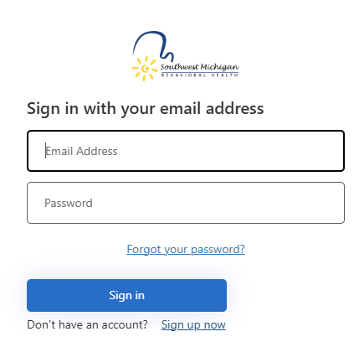

* 1. Follow these steps for signing up:

Step 1. Patient Lookup – Enter your first and last name, date of birth, Medicaid ID and last four digits of your Social Security Number.

Step 2. If the system finds your patient record, then you will be prompted to set up a user ID (your e-Mail address) and password.

Step 3. Agree to the terms of service by checking the box.

Step 4. The account will be created, and your information will be sent to be verified. This step may take up to 12 hours to load your data to the application where you can then access it.

Step 5. Once loaded into your app, you can use the app to search and display patient claims data which includes:

* Organization information
* Coverage information
* Explanation of Benefit

1. **Currently Available Third-Party Apps a Beneficiary can Use (Check back periodically for additions to this list)**